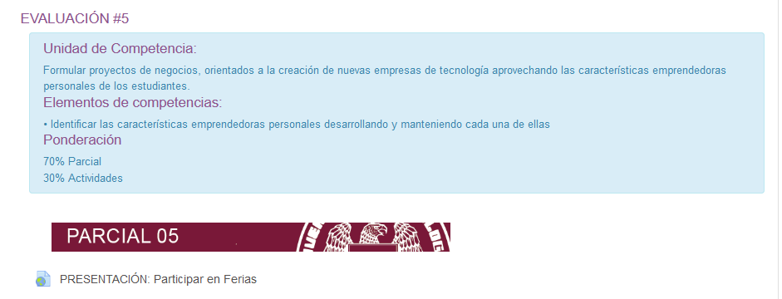

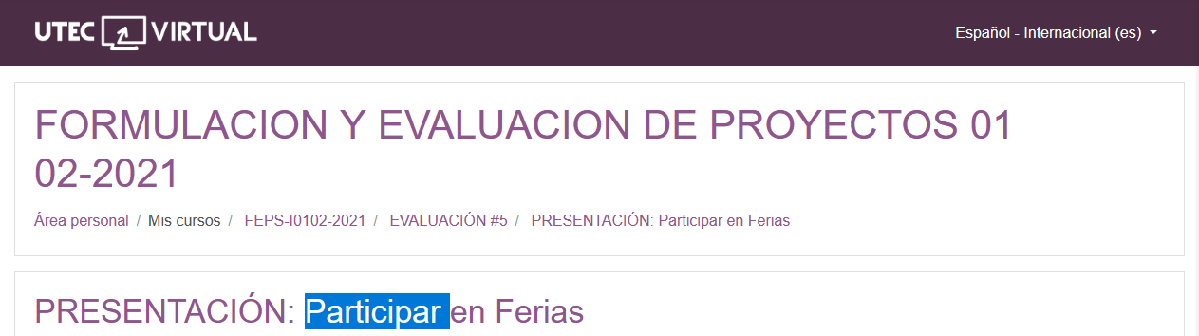

<https://www.slideshare.net/ajaraujo/participa-feriav2>